Objectives:

* Creating an Applet Form

**There are 2 print screens/code copy, each worth 50%**

Complete the following task below using an Applet.

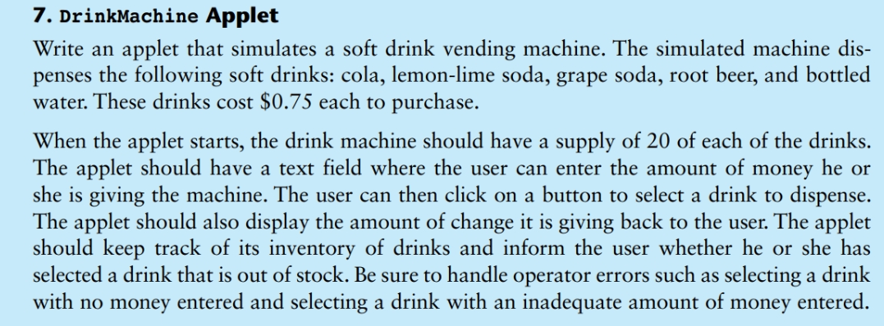

**#1 print screen the output below here**

**#2 copy and paste the code below here**

**Submit this document to Module 10 Homework #8**